LAB Logbook
Name:Rahul reddy
SID:2535824

LAB-1
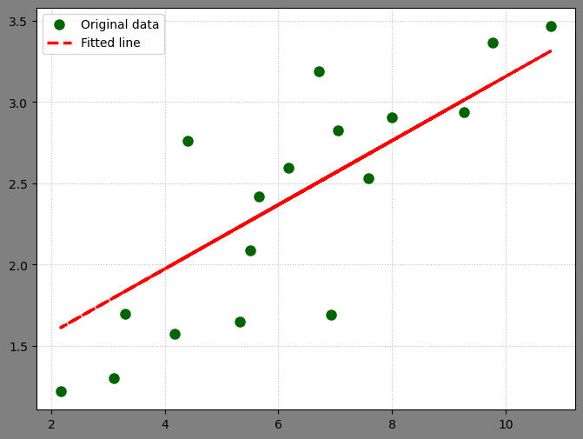

LAB-2
- The Accuracy of the improved model is 0.915.
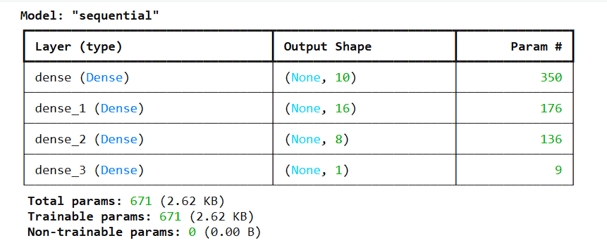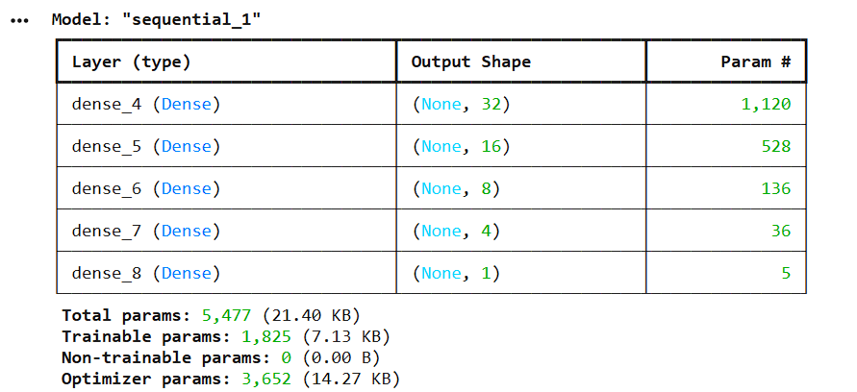
- O1 = 0.8291
O2 = 0.8291

